Lloyd Rainier P. Vitudio

Challenge #12

**Additional How Tos**

Scroll Indicator

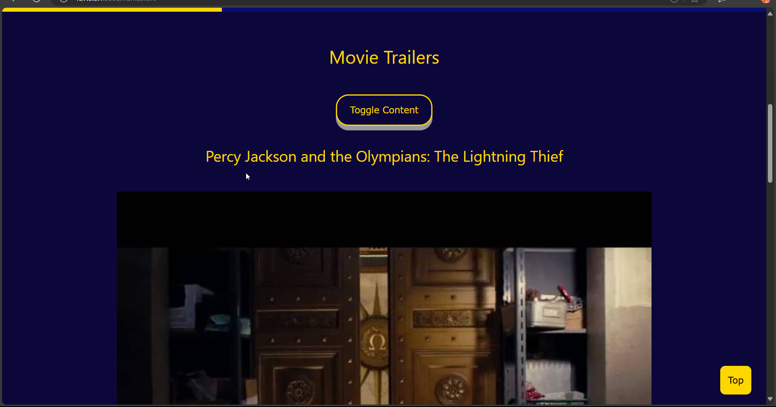

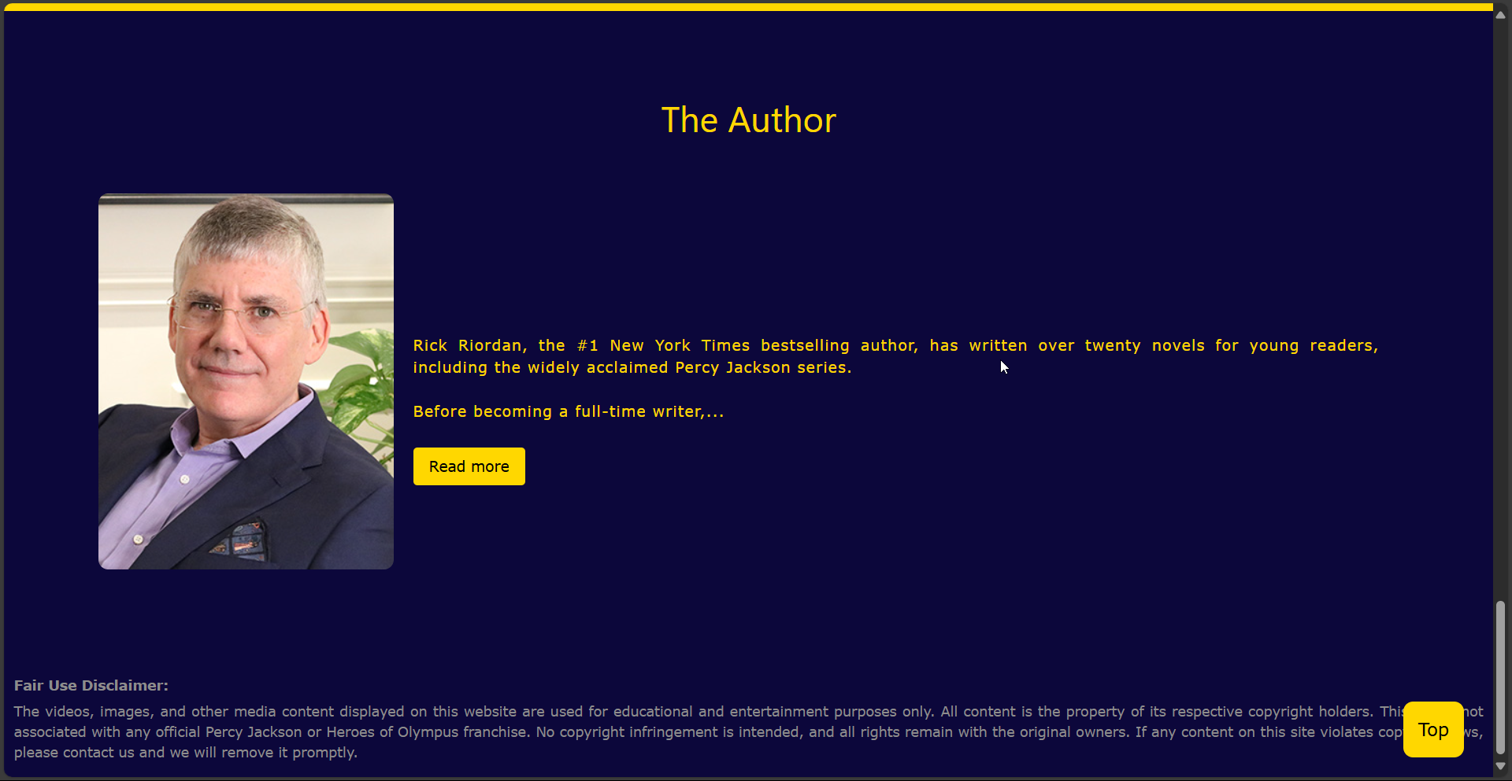

Typing Effect

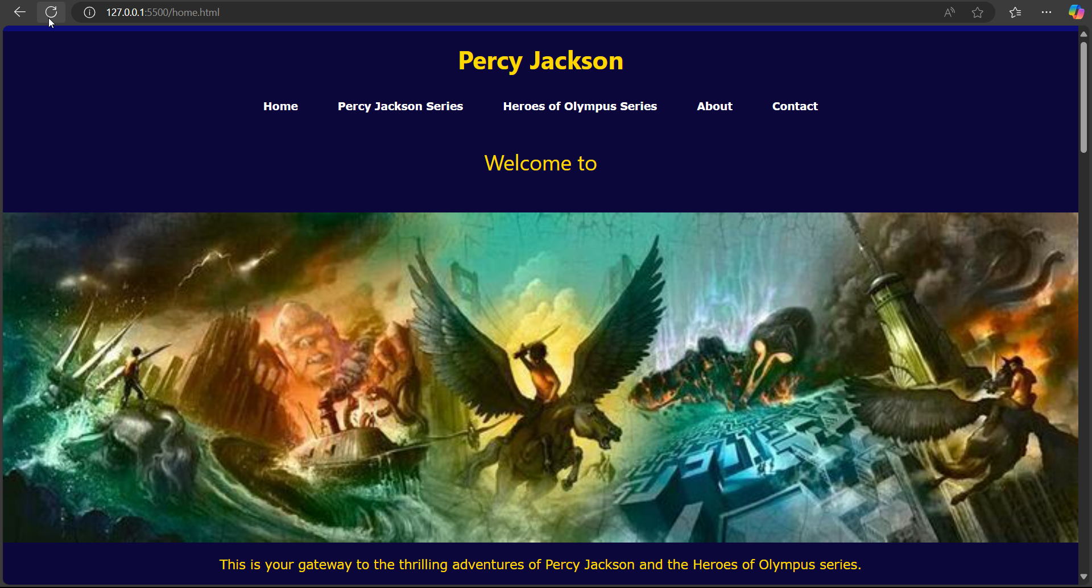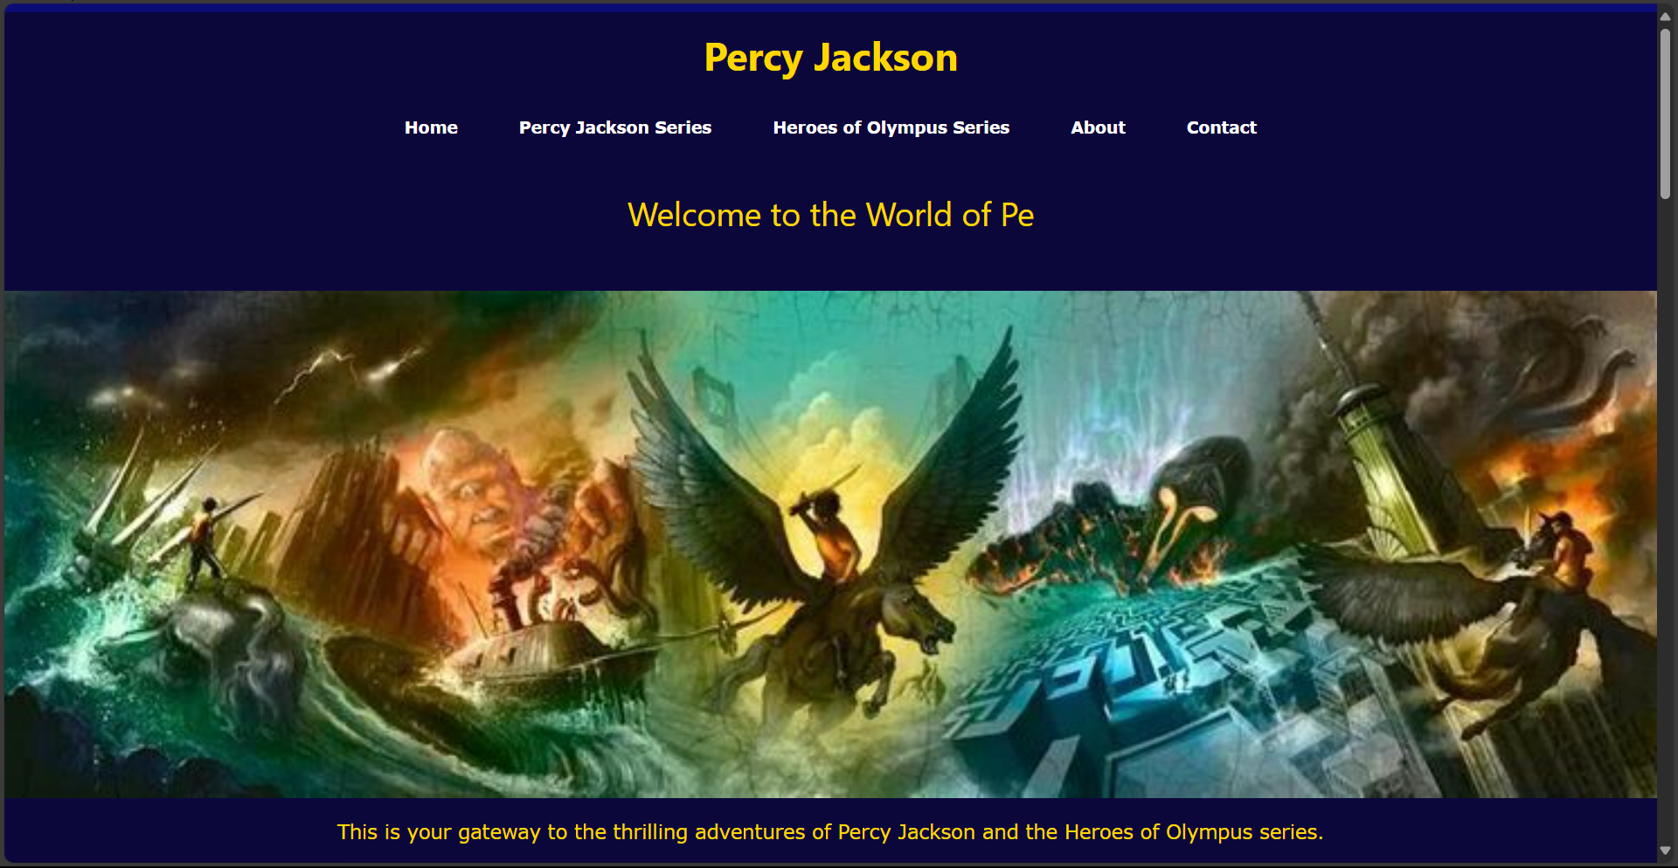

Read More Read Less Button

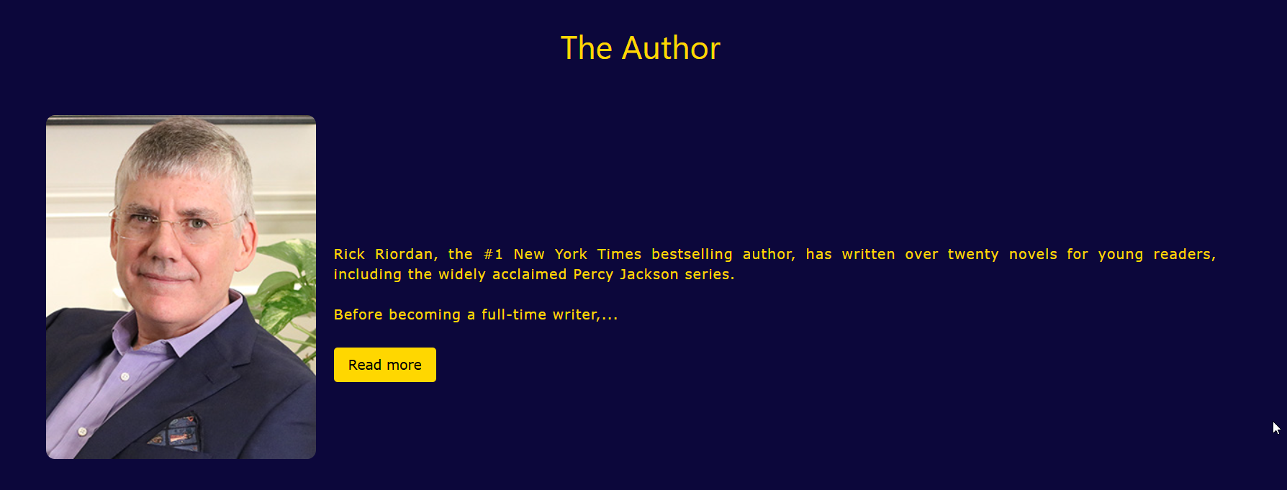

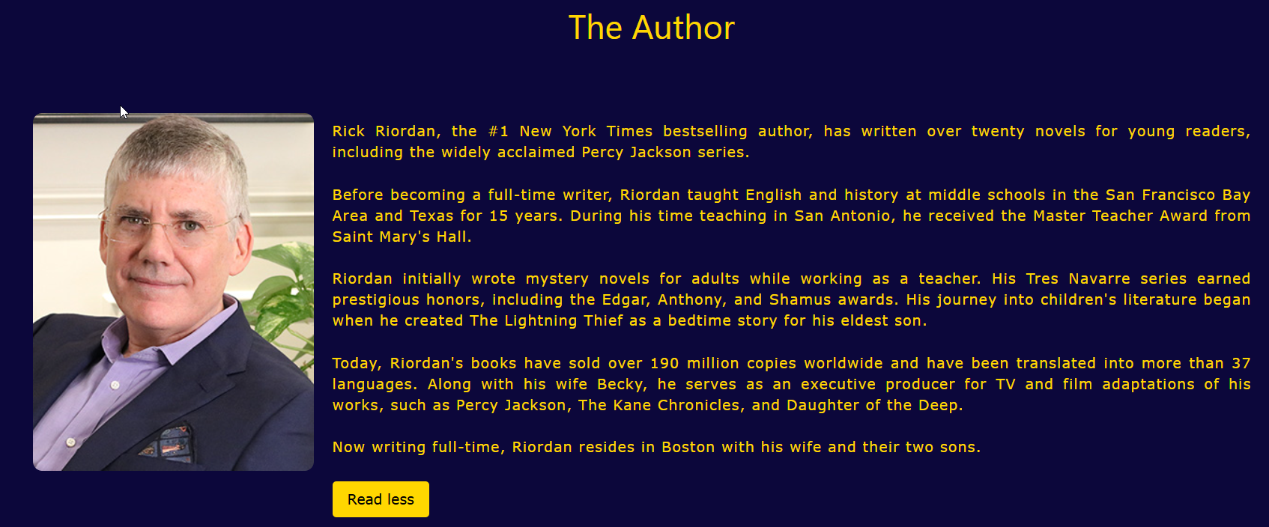

Shake an Image

.lloyd:hover{

    animation: shake 0.5s;

    animation-iteration-count: infinite;}

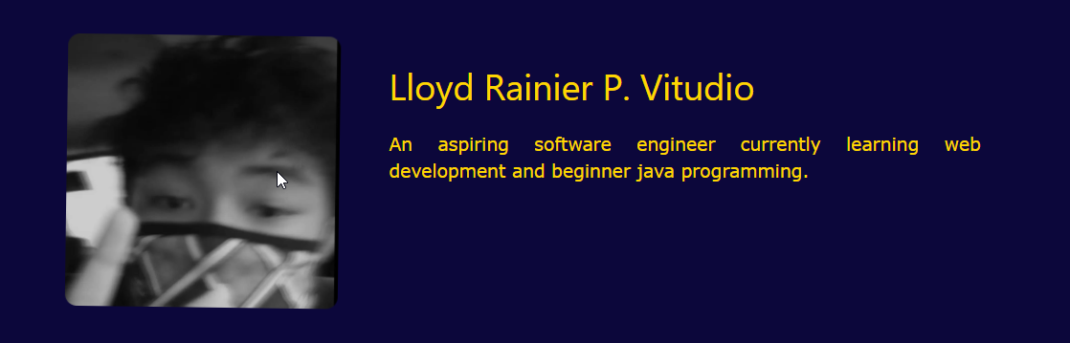

Skill Bars

